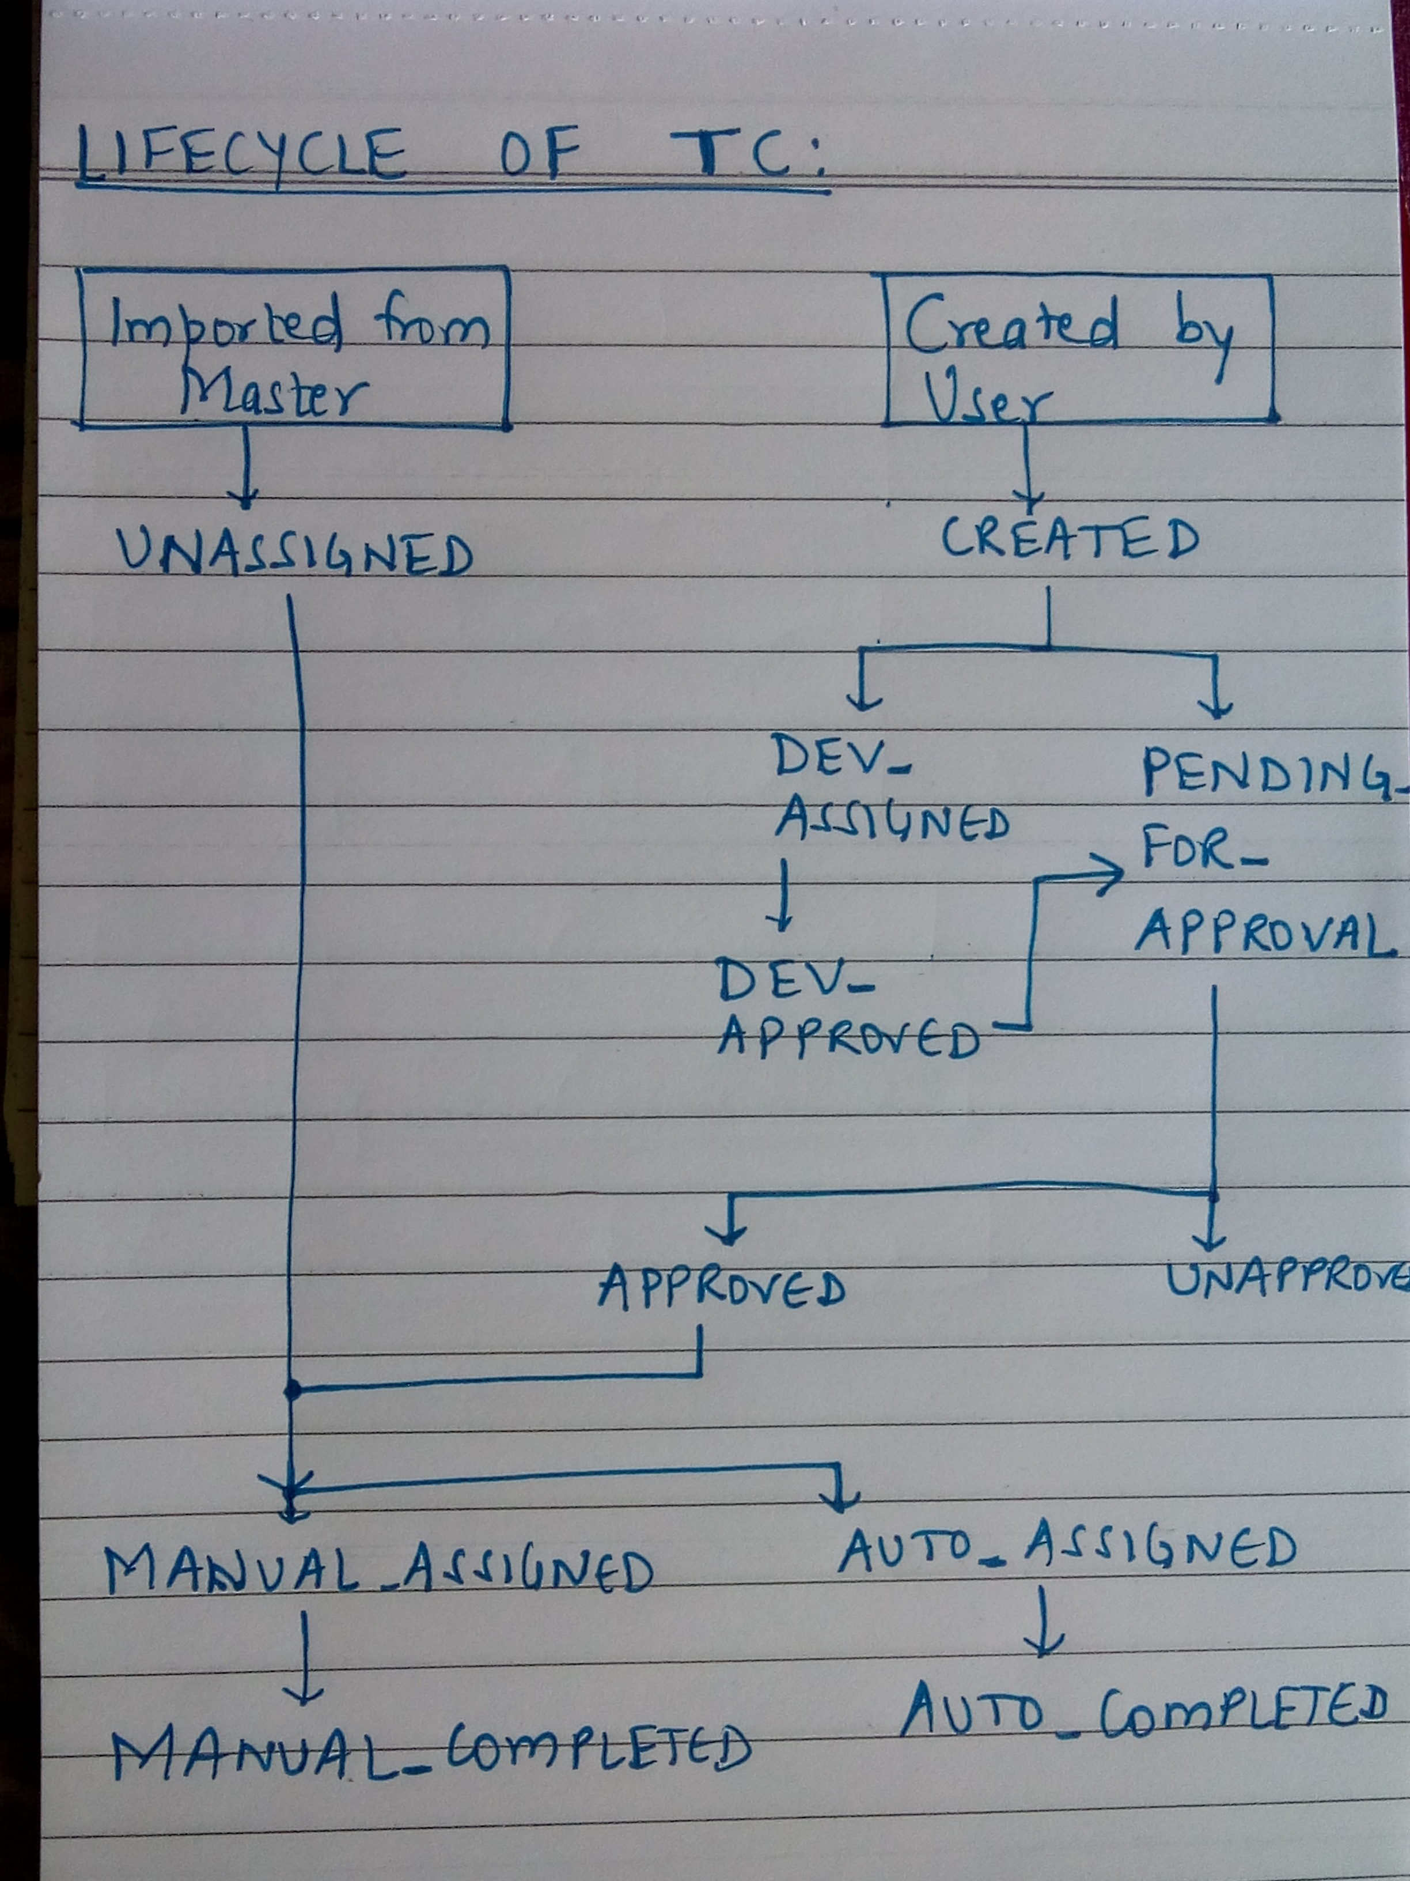
Yatish, Bharati and Vishal reviewed the release portal and there were updates to make the release portal usable for all of us.

Highlights were:

1) LifeCycle of TC
PLEASE REFER ABOVE IMAGE

2) Role based Portal.
All of us will be assigned to single or multiple roles as follows:
‘ADMIN’, ‘QA’,’DEVELOPER’,’MANAGER’,’EXECUTIVE’
Purpose: CRUD and View will be resricted accordint to the role.

Page: Manage Release
Only ‘MANAGER’ will be allowed for CRUD.

Page: Dashboard, QAStrategy
Only ‘MANAGER’ will be allowed for EDIT. All others have VIEW

Page: Test Metrics
FUNCTION | ADMIN | QA | MANAGER | EXECUTIVE | DEVELOPER
Create TC | YES | YES | NO | NO | YES
Edit TC | YES | YES* | NO | NO | YES**
Delete TC | YES | NO | NO | NO | NO
Assign TC to others | YES | NO | YES | NO | NO
Assign TC to self | YES | YES | YES | NO | NO
Approve TC | YES | NO | NO | NO | NO
Update Status of TC | YES | YES | YES | NO | NO

* - Can EDIT Status, Build, CardType, Description, Notes, Steps, Expected Behavior, Working Status
** - Can EDIT Status, Build, CardType, Description, Notes, Steps, Expected Behavior, Working Status which are in Status=DEV_ASSIGNED

3) Test Metrics View
names might be verbose, but functionalites in corresponding tabs are required as follows

Role:QA
A) Test Case Distribution
B) Test Cases Status
C) Create Test Case
D) Assigned TCs for Regression
E) Assigned Tcs for Automation
F) Pending Tcs For Getting Approved

Role: ADMIN
A) Test Case Distribution
B) Test Cases Status
C) Create Test Case
D) Pending Tcs For Approval
E) Pending Tcs for Assignment

